**Fundamentals of Data Science Final Project Proposal  
Football Statistic Analysis**

**Project Title**

* 1. **Analysis of Football Statistics**

**Group Members and Roles**

1. **Abdul Moiz – Documentation and Design**
2. **Nicholaus Santo – Ideation and Design**
3. **Problem Analysis**
4. **The Problem That We Want to Solve**In this day and age, football is a very big sport with a very big community. On a daily basis, there can be a multitude amount of football games that are played every day. Each and every football game that is played has its own unique results and outcomes with each of its own unique data and statistic.  
     
   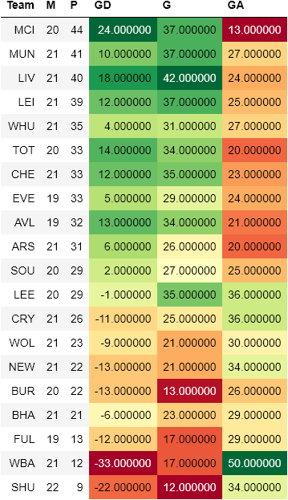  
     
   Those data can be used as a telltale of what can happen and the chances of stuff happening in a game based on previous games that has been played or other games that are similar, hence the importance of those statistics for the people such as the fans, coaches, trainers, and even the player themselves. However, on paper, those statistics are just numbers and letters, to discern those numbers and letters, it would take a long time and it would be very hard to visualize them based on just numbers and letters. Therefore, we are going to make an analysis and visualization of those said types of data.
5. **Related Works (Possible Ideas)**
   1. **Football Dribbling Skills with Elo System**[**https://towardsdatascience.com/evaluating-football-dribbling-skill-by-utilizing-the-elo-algorithm-9c6aa384b991**](https://towardsdatascience.com/evaluating-football-dribbling-skill-by-utilizing-the-elo-algorithm-9c6aa384b991)
   2. **Current Best Striker in Football**[**https://towardsdatascience.com/i-need-a-striker-for-my-team-who-is-he-going-to-be-examining-the-dataset-in-tableau-187e4c3f9692**](https://towardsdatascience.com/i-need-a-striker-for-my-team-who-is-he-going-to-be-examining-the-dataset-in-tableau-187e4c3f9692)
   3. **Game Predictions**[**https://towardsdatascience.com/epl-analysis-and-gameweek-22-prediction-91982b809802**](https://towardsdatascience.com/epl-analysis-and-gameweek-22-prediction-91982b809802)
   4. **Comparison of Football Team Performance**[**https://www.footballytics.ch/post/analytics-practice-compare-team-performance-fairly**](https://www.footballytics.ch/post/analytics-practice-compare-team-performance-fairly)
   5. **Comparison of Football Players Performance**[**https://www.footballytics.ch/post/data-analytics-practice-comparing-players-fairly**](https://www.footballytics.ch/post/data-analytics-practice-comparing-players-fairly)
6. **Dataset and Preprocessing**
   1. **The Data**The data that we will be using can be found in this website:  
      **https://fbref.com/en/**Using the said website, we can find and export statistics regarding team performance, the number of goals that can be scored within a season, history of clubs, history and individual statistics of a player.  
      The data would look as follows:  
      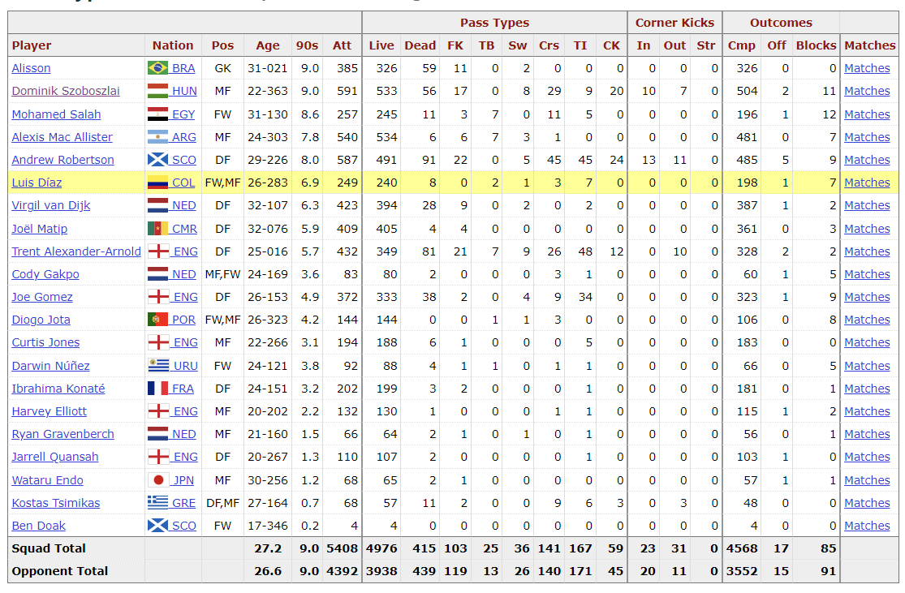  
      The data above is a data of Liverpool players passing rate throughout the season of 2022 to 2023
   2. **Preprocessing**Before we visualize the data, we need to find a suitable data for us to visualize and what can the data be used for. The data above can be processed to find out on who has made the most passes throughout the season or who has made the most outcome out of those passes.
7. **Model and Techniques**
   1. **Python**The python language will be the main language that can be used to create and code the visualization as the language is easy to work with and provides many resources regarding data analysis.
   2. **Matplotlib**Matplotlib is an open library that can be utilized with python to create static, animated, and interactive visualizations of a dataset.
   3. **Tableau**Tableau is a software different than python that can be used to visualize data with business orientation.
   4. **Pandas**Pandas is also a library similar to matplotlib with the difference being that pandas are made and used for manipulating data and analyzing them. Not for visualization.